BEARINGS
Pearson Edexcel - Tuesday 19 May 2020 - Paper 1 (Non-Calculator) Foundation Tier

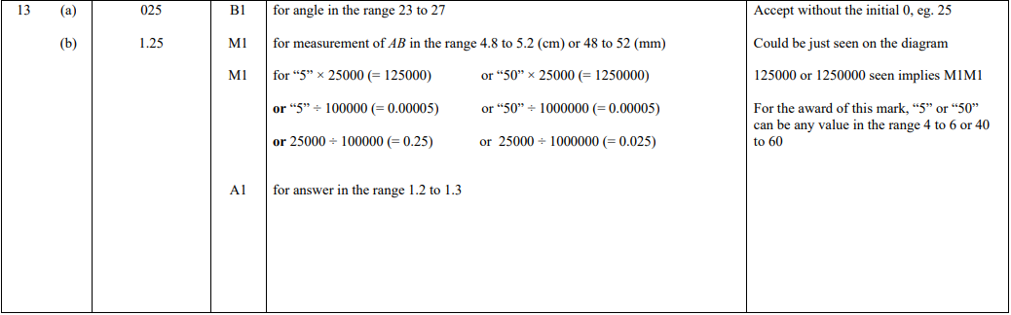

Pearson Edexcel - Monday 6 November 2017 - Paper 2 (Calculator) Foundation Tier

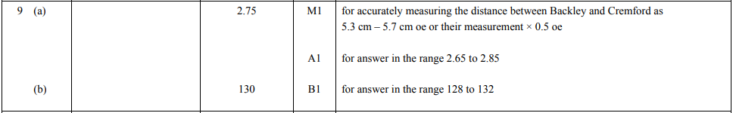

Pearson Edexcel – Specimen 2 - Paper 3 (Calculator) Foundation Tier

OCR Thursday 07 November 2019- Morning (Non-Calculator) Foundation Tier
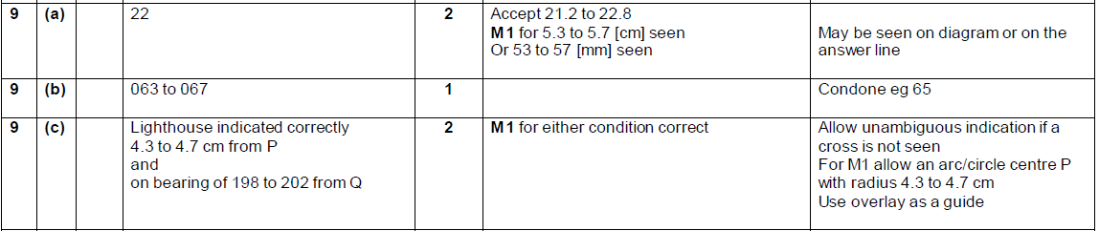

OCR Thursday 25 May 2017 – Morning (Calculator) Foundation Tier
- 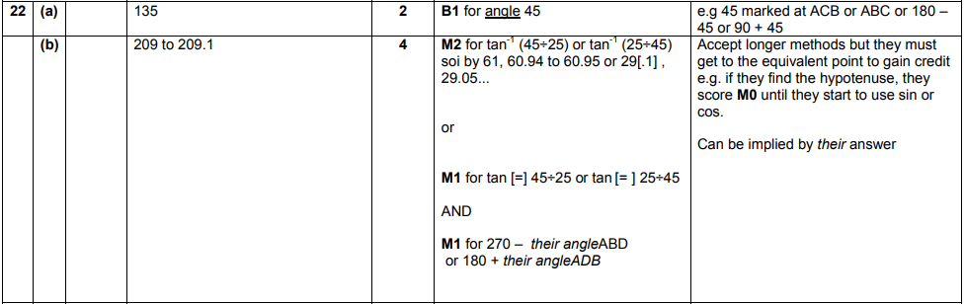
OCR Thursday 8 June 2017 – Morning (Non - Calculator) Foundation Tier

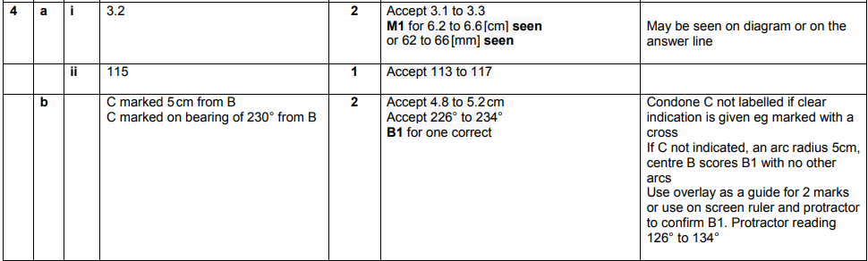
OCR Sample Question Paper 1 – Morning/Afternoon (Calculator) Foundation Tier

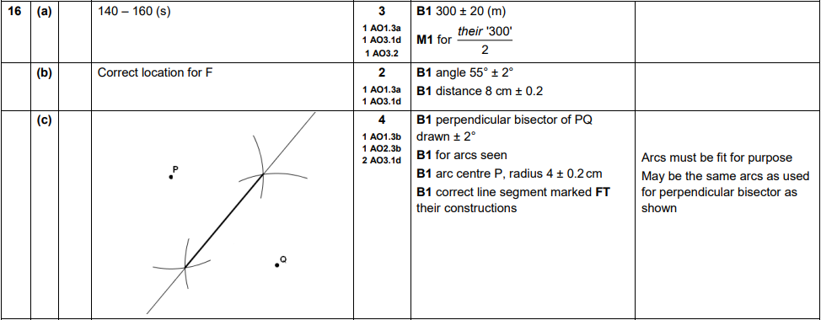

AQA Tuesday 21 May 2019 – Morning (Non-Calculator) Foundation Tier

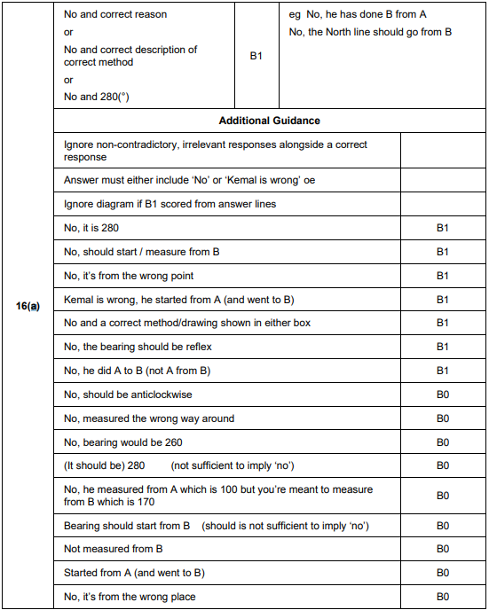

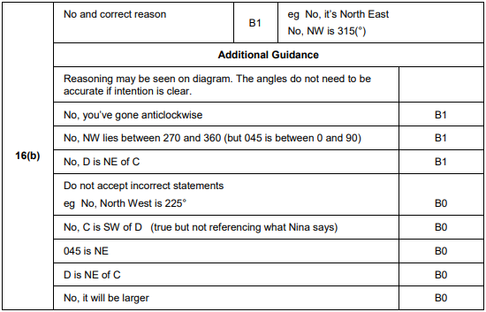
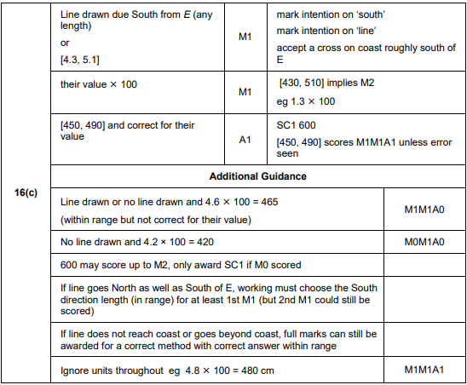

AQA Thursday 8 November 2018 – Morning (Calculator) Foundation Tier

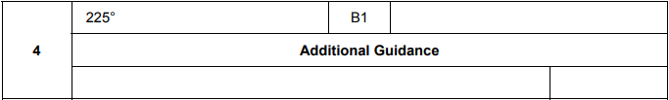
AQA Thursday 7 June 2018 – Morning (Calculator) Foundation Tier

